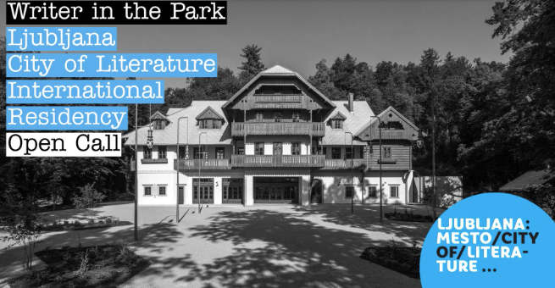

Ljubljana, the capital of Slovenia, was a World Book Capital in 2010. After being awarded a UNESCO City of Literature in 2015, it joined a growing world-wide network of cities and committed to actively promote literature, reading culture, and engage in activities that would strengthen the collaboration in the field of writing and publishing.
Ljubljana bursts with a vibrant art scene and offers an array of diverse literary events from alternative performances to big international festivals. The highly regarded residency, established in 2018, offers peace and quiet for uninterrupted writing, yet it also offers the possibility to actively engage in the city’s literary life.
Note: Part of the application is a mandatory letter of recommendation, signed by an organization from your chosen City of Literature. A Google account is required for the file upload to work.
Deadline for submissions: January 5, 2024.
👉APPLY HERE:
https://forms.gle/K7HZ8yWgKotfDrxT6
What
Ljubljana, a UNESCO City of Literature since 2015, offers two one-month residencies for writers at the Švicarija/Swisshouse Creative Centre, which is part of the International Centre of Graphic Arts.
When
One month per residency/applicant. Possible periods are as follows (dates cannot be changed, but a shorter stay is possible if necessary as a result of travel arrangements):
March 1–31, 2024
November 1–30, 2024
Who
The residency is aimed at foreign published writers with a palpable, factual relation with any of the other UNESCO Cities of Literature that has to be apparent and described as part of the application. This means the applicant was or has been living in one of the other cities of literature or is related to a city of literature through work. For reference, consult the list of eligible cities.
The applicant must have published at least one book of fiction (be it prose, poetry or drama) in their language. There are no restrictions regarding age, race, gender, nationality or other personal/aesthetic preferences. Though writers of all genres are currently welcome to apply, a specific focus might be chosen for calls in the following years.
What we offer
Each resident will get a sum amount of the grant and travel expenses of €1250 gross in total (details regarding potential wire-transfer charges and other expenses can be found in the contract that can be sent to the applicant upon request). Each resident will stay in their own, separate and fully equipped apartment with a kitchenette at Švicarija, possibly along other residents, artists, and exhibitions hosted at the premises.
Local public transportation costs will be covered, including airport transfer (Ljubljana Jože Pučnik Airport). Access to the Internet will be provided. Through targeted activities and networking possibilities, suited to each resident’s profile, the organisers will help them get to know the vibrant art and literary scene in Ljubljana. If requested, opportunities for public presentation of the residents’ work will be made possible, as well as meetings with translators, editors, other writers etc. if necessary and/or applicable. During the resident’s stay, some group activities, such as meetings with the organizer, publishers etc., may be scheduled.
Residents are required to take care of medical insurance and are responsible for their meals and household. Additional guests cannot be hosted.
What we expect
The resident is encouraged to show an interest, and partake, in local literary events and other related activities – which will be coordinated according to other local events as well as the needs and interests of the given resident. However, if the resident so wishes, they may request not to be distracted in order to use the time and space for writing.
Location
Švicarija/Swisshouse Creative Centre is a cultural, educational and social hub located in the heart of Ljubljana’s central park – situated just a few steps from the city centre – which offers public programmes, studio facilities for local artists, and residencies for international artists and experts. Švicarija is part of MGLC – International Centre of Graphic Arts, a specialised museum, producer of printed and contemporary art, and provider of artist residencies, based on the heritage of the 20th century art of printing and Biennial of Graphic Arts, Ljubljana, world’s oldest printmaking biennale which has been running uninterrupted since 1955.
The rather spacious building might seem empty at times or crowded at others, depending on current exhibitions and the number of residents or artists currently working in their studios. In general, Švicarija is marked by a creative, if particular, atmosphere. Peaceful and serene because of the closeness of nature, yet vibrat because of it’s artistic program and the proximity to the city centre.
🚧 Note: Downstairs, Švicarija hosts a restaurant which might host wedding receptions on Saturdays (particularly during summer months). If such events might interfere with your work, opt for the autumn timeframe, but be advised that some evenings might still get a bit noisy.
🙋 Note: Švicarija is located at the edge of the forest. Though it’s very close to the city centre, it can be reached only on foot (except for prearranged arrival and departure). It’s a short walking distance, but requires walking uphill through the park.

